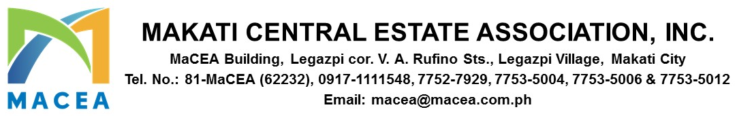

September 12, 2024

MEMORANDUM CIRCULAR 2024 – 005

FOR : ALL MEMBERS/BUILDING ADMINISTRATORS

RE : 2025 ASSOCIATION DUES

Dear Members,

As we continue to further improve the Makati Central Business District, it is of great importance to note the significant role of each member in achieving greater heights for the Association. Over the years, your full trust brought MaCEA to what it is right now- an Association recognized locally and globally. As always, your Association is committed in providing high- quality services having in mind the very much needed cooperation and full support from each.

While we have kept the service quality in the past years, the cost to operate the Association now requires some adjustment due to inflation. After a careful consideration and comprehensive assessment, your Board of Governors approved a series of association dues increase which started last year. In its recent meeting, the Board of Governors approved the 2nd tranche of association dues effective January 1, 2025:

The new dues structure will have an effective minimal impact versus current. Please see attached sample computation.

As customary, the Association dues must be paid in full within the first quarter of each year. Beyond that period, it is already subject to interest and penalty surcharge of three percent (3%).

We are hoping for your kind understanding and full support as we move forward in achieving greater goals for MaCEA.

For any questions or clarifications, please feel free to call us at (02) 7752-7929 / 09171111548. You may also visit us at MACEA Office, VA Rufino corner Legazpi St. Legazpi Village, Makati City.

Thank you very much.

Sincerely,

PAUL GETTY E. GRANADA
General Manager

