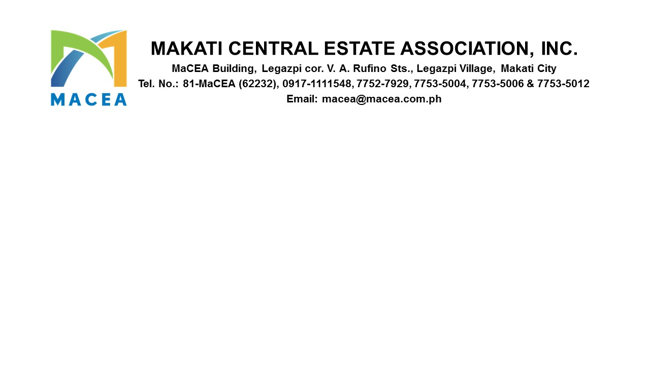

November 13, 2025

MEMORANDUM CIRCULAR 2025 – 008

FOR : ALL MEMBERS/BUILDING ADMINISTRATORS
RE : 2026 ASSOCIATION DUES

Dear Members,

As we continue to improve the Makati Central Business District, we remain committed to serving our community. Your support and participation help MaCEA do its work and move forward together.

MaCEA remains firmly committed to delivering high-quality services and maintaining the standards that our community deserves. To sustain these efforts amid rising operational expenses brought about by inflation and government-mandated wage increases, the Management conducted a thorough review and assessment of our financial requirements.

Following this evaluation, the Board has approved the third tranche of the Association dues adjustment, which will take effect on January 1, 2026:

These adjustments are necessary to ensure that we can continue providing efficient operations, maintain the cleanliness and orderliness of the district, and support the overall operations of the Association. Despite the increase in inflation, costs for manpower, materials, logistics, and essential services, we have taken great care to keep the adjustments as minimal as possible while still allowing MaCEA to meet current demands and sustain service quality.

We sincerely appreciate your understanding, cooperation, and continued support as we work toward even greater accomplishments for MaCEA and the community we proudly serve. With your partnership, we are confident that we can further enhance the environment, efficiency, and prestige of the Makati Central Business District.

For inquiries or clarifications, please feel free to contact us at (02) 7752-7929 / 0917-111-1548, or visit us at the MaCEA Office located at VA Rufino corner Legazpi St., Legazpi Village, Makati City.

Together, we move forward—stronger, more capable, and more committed to building a thriving district for all.

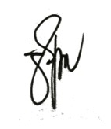
Sincerely,

PAUL GETTY E. GRANADA
General Manager

