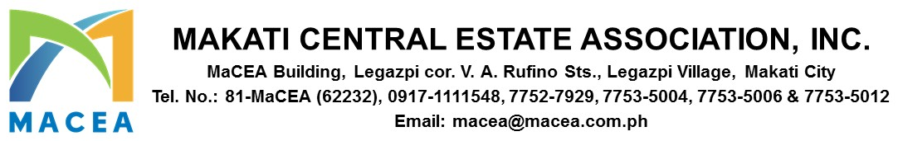
November 7, 2025
FINANCE ADVISORY – 2025 - 0003
FOR : ALL MEMBERS/BUILDING ADMINISTRATORS
RE : GARBAGE BILLING INVOICE FOR THE MONTH OF NOVEMBER AND DECEMBER 2025
_____________________________________________________________________________________
Dear Members,
As part of our year-end activities, please be informed that the Garbage Dues billing for the months of November and December 2025 will be released starting November 12, 2025.
This early release is intended to provide ample time for processing and to accommodate the upcoming holiday schedule.
You may send your payments through any of the following options:
- Onsite Payment
You may pay directly at our office located at:
MACEA Building, Legazpi corner V. A. Rufino Streets, Legazpi Village, Makati City
Office hours: Monday to Friday 8:00 am to 5:00pm

- Bank Deposit / Online Transfer
Please follow the steps below to complete your payment via bank deposit:
Step 1: Make your payment using the bank details provided below:
  - Bank Name: BANK OF THE PHILIPPINE ISLAND (BPI)
  - Account Name: MAKATI CENTRAL ESTATE ASSOCIATION, INC.
  - Account Number: 3021002509

Step 2: Email the following documents to accountingassistant@macea.com; quiban.mimi@macea.com.ph; delacruz.tin@macea.com.ph
  - With Subject: Payment for Invoice (Indicate the Billing Invoice Number -BI#); Company or Building Name of the Payor
  - A copy of the validated deposit slip
  - A copy of your BIR Form 2307 (Certificate of Tax Withheld)
**The sender will be notified once the Collection Receipt is ready for pickup.

- Check Pick-Up Service
Please be informed that check pick-up services will be available on the 3rd and 4th Wednesday of November 2025. Regular monthly services will resume in January 2026 following the year-end break. To facilitate this option, please follow the steps below:
Step 1: Take a clear photo of the following documents:
- The check
- Your BIR Form 2307 (Certificate of Tax Withheld)

Step 2: Email the following to accountingassistant@macea.com; quiban.mimi@macea.com.ph; delacruz.tin@macea.com.ph :
  - With Subject: Payment for Invoice (Indicate the Billing Invoice Number -BI#) / Company or Building Name
- The photo of the check and Form 2307

Important Payment Guidelines: Please take note of the following requirements when processing payments to MACEA:
- All checks must be made payable to: MAKATI CENTRAL ESTATE ASSOCIATION, INC.
- Creditable Withholding Tax (BIR Form 2307) Details
  - Payee Name: MAKATI CENTRAL ESTATE ASSOCIATION, INC.
  - Address: MACEA Building, Legazpi corner V. A. Rufino Streets,
Legazpi Village, Makati City
  - TIN: 000-473-917-000
- Payment should be equal to:
  - Billing Invoice = Check + BIR Form 2307
  - Billing Invoice = Check
Please follow the applicable option based on your company’s withholding tax obligations.
We trust this advisory provides clear guidance and helpful information. Should you have any questions or require further clarification, please don’t hesitate to reach out at: 0917-1111548, 7752-7929, 7753-5006, 7753-5012 macea@macea.com.ph
Thank you for your understanding and support.
Warm regards,
ROCHELLE A. LONTIONG
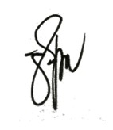
Finance Manager

PAUL GETTY E. GRANADA
General Manager

