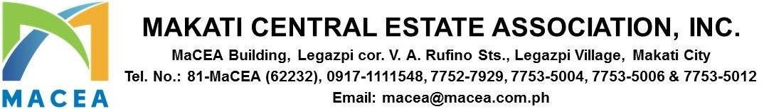

ADVISORY 2025-0051

DATE : NOVEMBER 13, 2025

TO : ALL MEMBERS/BUILDING ADMINISTRATORS

SUBJECT : REGISTRATION GUIDELINES FOR THE 2025 UNIFIED SECURITY SUMMIT

Dear Members,

Please be guided by the following registration guidelines for the 2025 Unified Security Summit:
- Due to limited number of slots, registration to the summit will be limited to the following MACEA Members:
- Authorized Lot Representative
  - Authorized Lot Representative
  - Property Managers / Building Administrator
  - Security Manager/ Security Detachment Commander / Assistant Detachment Commander
- Slots will be on a first-come, first-served basis
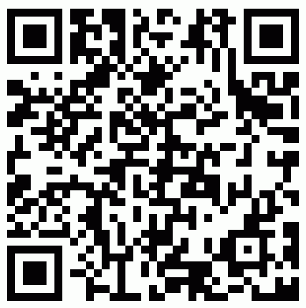
- Scan the QR code or click the link to register

http://www.render.jotform.com/form/253131855709460

- Accomplish the pre-registration form
- A confirmation email will be sent to all successful registrations.
- During the event day, kindly present any proof of identification

We will also offer a limited free shuttle service from the MACEA Office and Jaime Velasquez Park to the event venue on November 21, 2025. There will be two departure schedules — 8:00 AM and 8:15 AM. Should you wish to avail of the free shuttle service, please proceed directly to the MACEA Office or Jaime Velasquez Park on the day of the event.

Thank you.
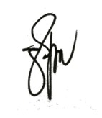
For and On Behalf of Makati Central Estate Association, Inc.

PAUL GETTY E. GRANADA
General Manager

