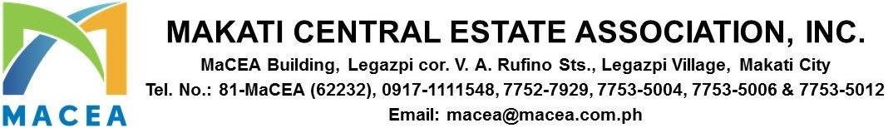

ADVISORY 2025-0050

DATE : NOVEMBER 12, 2025

TO : ALL MEMBERS/BUILDING ADMINISTRATORS

SUBJECT : 2025 UNIFIED SECURITY SUMMIT

Please be informed that the Sustainability Summit originally scheduled on November 21, 2025 will be cancelled. A separate advisory will be issued to inform everyone of the new date once finalized.

Meanwhile, we are pleased to announce the conduct of the 2025 Unified Security Summit, organized by MACEA in partnership with the Makati City LGU, Barangays Bel-Air and San Lorenzo, and other estate associations in Makati namely Ayala Center Estate Association (ACEA), Circuit Makati Estate Association (CMEA), and Paseo de Magallanes Commercial Center (PDMCC). This will be held on November 21, 2025 from 9:00AM onwards at Hall A and B, Space at One Ayala Avenue, Makati City.

The summit aims to increase security awareness and apprise our members with the latest crime and incident statistics, latest modus operandi during Holiday Season, proper handling of mendicants, and other security related matters. We have invited several keynote speakers from our partner in law enforcement particularly the Chief of Police of Makati, Makati City Public Safety Department, and our own security team.

With this, we would like to invite everyone to attend the security summit. This will be a great tool that will help our members and locators in keeping their communities safe and secure specially during the Holiday Season.

Kindly register through this QR code below. Deadline for registration is on November 14, 2025.


Thank you.
For and On Behalf of Makati Central Estate Association, Inc.

PAUL GETTY E. GRANADA
General Manager

