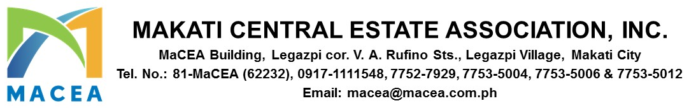

ADVISORY 2025-0034

DATE : SEPTEMBER 5, 2025
TO : ALL MEMBERS/BUILDING ADMINISTRATORS
SUBJECT : SURVEY FOR THE PROPOSED MAKATI BUS RAPID TRANSIT (BRT) SYSTEM

Dear Members,

We recognize the daily challenges faced by commuters and residents within the Makati Central Business District (CBD). In response to these, MACEA, in partnership with Ayala Land Inc. and SYSTRA Philippines Inc., is conducting a study to explore the feasibility of a dedicated Bus Rapid Transit (BRT) system in the Makati CBD.

This initiative aims to significantly improve connectivity, ease traffic congestion, and enhance the commuting experience in and around the CBD.

To help ensure that the proposed BRT system is responsive to your actual needs, we are inviting you to take part in a brief online survey. Your feedback will be critical in shaping the planning and design of the system—including the location of stations and overall service features—to prioritize comfort, reliability, and safety.

All survey responses will be kept confidential and used solely for this study. We adhere strictly to the Data Privacy Act of 2012 (RA 10173).

As a token of appreciation, completing the survey will automatically enter you into a raffle draw for a chance to win ₱2,000! Get a chance to be one (1) of ten (10) lucky winners of ₱2,000 via GCash.

To participate, scan the QR code below or click the link -
https://docs.google.com/forms/d/e/1FAIpQLSf_n5ewyZKbZrSvjN9obovbw0SMDGrnJQb5fC7GLcWSjfyb4g/viewform:


Your voice matters. Help shape the future of transportation in Makati CBD.

Thank you for your continued support and participation.


For and On Behalf of Makati Central Estate Association, Inc.

PAUL GETTY E. GRANADA
General Manager

