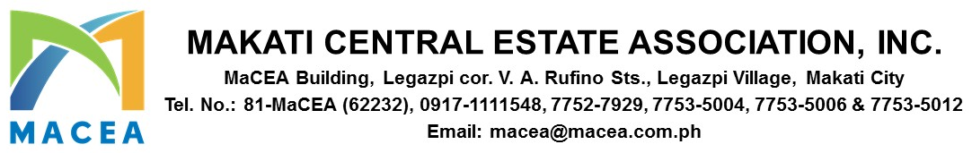

ADVISORY 2025-0030

DATE : AUGUST 12, 2025
TO : ALL MEMBERS/BUILDING ADMINISTRATORS (LEGAZPI VILLAGE)
SUBJECT : ON-SITE PROPERTY INSPECTION BY THE MAKATI CITY ASSESSMENT DEPARTMENT

Dear Members,

Please be informed that the City Government of Makati – Assessment Department will begin conducting on-site property inspections within our barangay starting August 12, 2025. This is in line with their efforts to update the Schedule of Market Values (SMV) for real properties in the city.

This initiative is part of the implementation of Republic Act No. 12001, also known as the Real Property Valuation and Assessment Reform Act (RPVARA), which aims to enhance the efficiency, accuracy, and transparency of Makati’s real property tax administration system.

We kindly ask for your full cooperation and support during the inspection process to ensure a smooth and successful implementation.

Should you have any questions or concerns, you may contact the Makati Assessment Department at (02) 8870-1372 or email them at assessmentdepartmentmakati@gmail.com.

Please see the attached letter from the Makati City Assessment Department for your reference.

For and on behalf of Makati Central Estate Association, Inc.


PAUL GETTY E. GRANADA
General Manager

