

ADVISORY 2024-0001

DATE : JANUARY 13, 2025
TO : ALL MEMBERS/BUILDING ADMINISTRATORS
SUBJECT : TEMPORARY ROAD CLOSURE (FUN RUN EVENT)

Dear Members,

We would like to inform you about the temporary road closure on January 18 and 19, 2025, for the TACbo Fun Run. During the event, Portions of Ayala Avenue, Paseo De Roxas, and Makati Avenue will be closed to vehicular traffic. Please refer to the map and traffic scheme details below for your reference.

We have attached a map and traffic scheme outlining the affected areas. We encourage you to review these details in advance to avoid any inconvenience.

Rest assured that traffic marshals and traffic control devices will be deployed to ensure continuous traffic flow.

Should you have any questions or inquiry, you may email us at macea@macea.com.ph or call us at 0917-1111548.

Please be guided accordingly.

For and on behalf of Makati Central Estate Association, Inc.


Philip Marco P. Dacanay
Operations Manager



PAUL GETTY E. GRANADA
General Manager

tACbo Fun Run Route

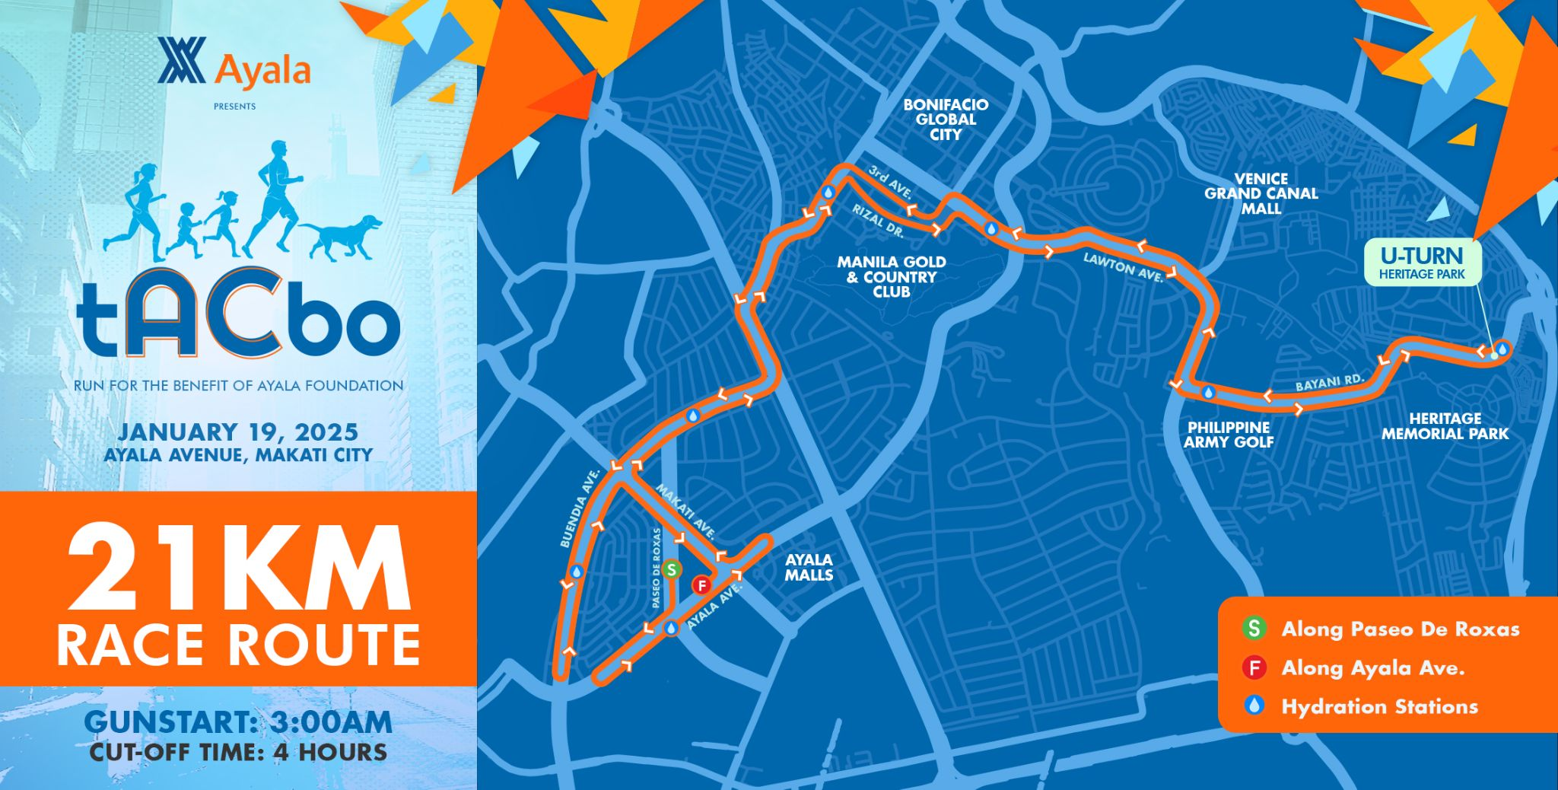

Temporary Road Closure
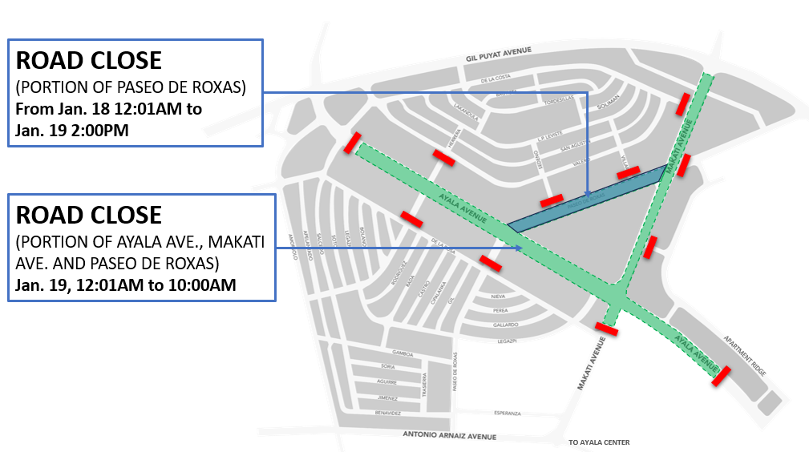

LOCATIONS |  | REMARKS
1 | Ayala Avenue (from Fonda St. to Salcedo St.) | ROAD CLOSED  Starting 12:01 AM until 10:00 AM on January 19, 2025. (SUNDAY)
2 | Makati Avenue (from Dela Rosa to Buendia)
3 | Paseo de Roxas (from Ayala Avenue to Makati Avenue)
ACCESS TO THE MAKATI CENTRAL BUSINESS DISTRICT
1 | From Gil Puya/Buendia | Take Ayala Avenue turn left on right on Salcedo St.
2 | From EDSA | Take Ayala Avenue then turn right to Apartment Ridge or turn left to Courtyard Drive
3 | For Public Utility Buses (PUB) | Take Gil Puyat/Buendia

