ANNEX A: ASSOCIATION DUES SAMPLE COMPUTATION
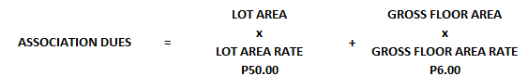
SAMPLE COMPUTATION
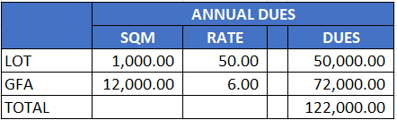

ANNEX B: SAMPLE IMPACT OF ASSOCIATION DUES INCREASE
- MID-SIZED OFFICE BUILDING

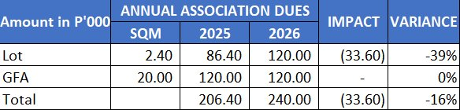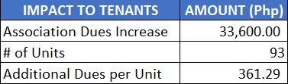

- RESIDENTIAL BUILDING
